

IPX Loop Application Rewrite – Phase1
Business Requirements Document

02/26/2026
Version 2.0
Written by FNF India

Document Approval
Version | Name | Organization | Approval Date | Approval Email
1.0 | Jason Hawes | IPX 1031 Exchange Service Inc. | 2/11/2026 | BRD got approved during the IPX weekly call
2.0 | Jason Hawes | IPX 1031 Exchange Service Inc. | 2/26/2026 | BRD got approved during the IPX weekly call

Document Change History
Date | Version | Author | Organization (Dept.) | Comments
02/09/2026 | 0.1 | Prabodha HC | FNFI & ADM | Initial Draft
02/10/2026 | 0.2 | Prabodha HC | FNFI & ADM | Include the Feature Overview of IPX Loop Application Rewrite – Phase1
02/11/2026 | 1.0 | Prabodha HC | FNFI & ADM | Baseline Version
02/26/2026 | 2.0 | Prabodha HC | FNFI & ADM | Excluding the Audit log/ Log statistics module in the Phase1

Table of Contents
1. Executive Summary 4
2. IPX Loop Application Rewrite 4
2.1. Business Objectives 4
2.2. Feature Overview of IPX Loop Application Rewrite – Phase1 5
3. Project Scope for IPX Loop Application Rewrite 5
3.1 In Scope 5
3.2 Out of scope 8
4. As-Is Process Flow 9
5. To-Be Process Flow 10
6. Non-Functional Requirements 11
7. Assumptions 12
8. Risks and Mitigation 12
9. Success Criteria 12
10. Appendix A: Glossary 12
11. Appendix B: Informational Purpose 13
11.1 Identification of Residential vs Commercial 13

Executive Summary
The IPX Loop Application has been in operation for over a decade, supporting IPX admins and sales representatives to
- Track and update the title orders through customer engagement (buyers, sellers and realtor agents) and promoting IPX 1031 exchange services
- Add, Edit and Delete the ‘Users’ to the system
- Add new ‘Templates’ and let the users update & delete them
- Add, Update and Delete ‘Groups’ into the system
- Assign orders to Sales Representatives
Please find the link for the existing IPX Loop Application: IPX Login Page
The IPX Loop application is being rewritten to implement new technology and modern programming languages, enhance user authentication and modernize UI/UX design, and transition the database architecture from the ‘FOW’ to the ‘CDP’ to enhance data integrity, support optimized queries, and ensure scalability

IPX Loop Application Rewrite

Business Objectives
The rewrite of the existing IPX Loop application is driven by the following business objectives:
- Implement AD authentication and access control (RBAC) management to meet FNF’s security and compliance standards.
- Transition from ‘Fidelity Order warehouse’ (FOW) to a centralized ‘Customer Data Platform’ (CDP) for backend data processing, fetching, and mapping into the IPX database, additionally sync back the data from IPX database into CDP.
- Ensure CDP and IPX data integrity, automation, and transparency through daily refresh and audit tracking mechanisms.
- Redesign the IPX Loop application with a contemporary, responsive user interface to improve usability and accessibility.
- Enable enhanced order management capabilities for Sales Representatives and Admins, including advanced filtering, tracking follow-ups, commenting and changing the order status.
System has 2 users
- Admin User
- End User (IPX Sales Rep)

Feature Overview of IPX Loop Application Rewrite – Phase1
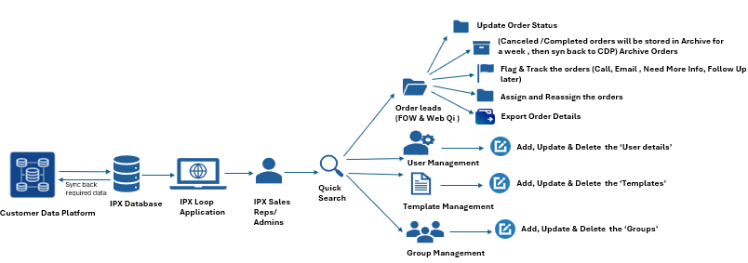

Project Scope for IPX Loop Application Rewrite

3.1 In Scope
    - User Authentication
- Implementation of secure login system with encrypted credentials (using Microsoft AD -Single Sign On) with session timeout features

    - Implement the access control based on roles to ensure structured access to IPX Loop Application
- Screen/Features-wise Role based access control - Matrix for Admins and Sales Representatives

Sl. No | Screen/Features | Admins | Sales Representative
1 | Secure Login (Microsoft AD-SSO) and Log Out | ü | ü
2 | Home – Dashboard and Order Management (Search orders, Filter Orders, View details, history, Update the order status, Flag Orders (Follow Up, Call, Email and Need more Information) and Tracking flag based on client’s comment, Assign or reassign Orders) | ü (All orders) | ü (only for Assigned orders)
3 | Delete Orders | ü | û
4 | Archive the Orders | ü | ü
5 | Download Order details | ü | ü
6 | Group Management (Create, Edit, Delete and Search) | ü | û
7 | Template Management (Create, Edit, Delete and Search) | ü | û
8 | User Management (Add, Edit, Delete and Search) | ü | û
9 | Monitoring the data sync back to CDP | ü | û

    - Order Management
- The order screen is expected to fetch the data from CDP (FOW & Web Qi)
- Display all the order details to admins, whereas Sales Representatives can only view the orders assigned to them.
- Admins can assign or reassign the orders to the Sales Representatives
- Sales Representatives can assign and reassign orders to other Sales Representatives as needed
- Enable the ability to flag orders for specific actions such as: Follow Up Later, Call, Email and Need More Information. Additionally, provide visual indicators for the above-mentioned flags
- Ability to track the client’s follow-up comments to monitor client interactions and plan appropriate next steps. The following predefined flags can be applied:
- Called – Left Voicemail
- Emailed
- No 1031 Ever
- Yes 1031 – Went with IPX
- Yes 1031 – Went with Competitor
- Need Follow-Up: Send more information, add to mailing list, Set up CE seminar
- View & update the order status as
- Open
- Closed
- Canceled
- View the new IPX exchange status as (for web Qi orders)
- D – Delayed
- P – Pending
- CNXP – Canceled Pending
- CNX - Canceled
- NPF – Note Payment File
- S – Simultaneous
- PS - Partial Simultaneous
- 45 F - Failed Non-ID (45F)
- Failed non-purchase (180F)
- Trans - Transfer to Reverse
- Tax Return Filed/completed
- Resc – Rescinded
- Display the orders for the following column and ability to filter it
- For FOW order details,
Branch Name, Date Opened, Division, File number, Flash code, Flash Name, Marketing source, Order Type, Property State, Property Price & Property type group etc.,

- For Web Qi exchange order details,
Exchange Number, Coordinator, Open date, Close date and Sales Rep and Relinquished property details, Replacement property details and contact information associated with the Property Exchange process.
- Advanced Search Capabilities - Introduce a new search tab with ability to search by:
- Email (relator, contact, etc.)
- Property address
- First name, last name of the Parties
- Exchange number
- Order numbers
- Sorting across all the visible fields and download capability in .XLSX and .CVS format
- Delete/hide orders from the UI with confirmation prompt

    - Archive and Sync back Orders
- If the new IPX order status is marked as ‘Canceled’ or ‘Closed’ or ‘Completed’ by a sales rep or closed externally (via FOW, Web Qi, etc.,) will be displayed in “Archived” screen
- Canceled or Closed or Completed orders should be removed from the system one week after closure and sync back to CDP

    - Template Management
- Ability to create and manage the templates and view the orders details accordingly, by adding the ‘role name’ and ‘associated headers’ for orders derived from the FOW and Web Qi
- Ability to edit and delete the templates
- Ability to search/filter for the different ‘Templates’

    - Group Management
- Ability to create and edit a group by adding the role name, description, select templates and select permissions to allow the users to perform the specific functionalities
- Ability to edit and delete the created groups
- Ability to search/filter for different ‘Groups’

    - User Management
- Ability to add users by entering the User’s first and last name, email Id, selecting the groups, State, flash codes & ZIP codes
- Ability to edit and delete the user’s details
- Ability to search/filter for different ‘Users’

    - UI/UX Enhancements
- Complete visual redesign of a decade old IPX Loop interface
- New modern Web UI framework
- Improved Navigation structure (Screen layout, and filters)
- Enhanced ‘responsiveness’ for desktop browsers (Microsoft edge & Chrome)
- Use of modern ‘interactive UI elements’ (Cards, tablets, icons, pagination)
- List of UI screens & accessibility for the users

Sl. No | List of UI Screens | Accessibility
1 | Home – Order management – View Order details | Admin & Sales Representatives
2 | Template | Admin only
3 | Group | Admin only
4 | User | Admin only
5 | Archive | Admins & Sales Representatives

    - Data Integration & System Enhancement
- Transition from FOW data source to centralized Customer Data Platform (CDP)
- Implement Data pipelines to fetch and load the data from CDP to IPX database
- Ensure data refresh synchronization every 24 hours for CDP
- Sync back the data changes in the IPX DB to the CDP
- Include monitoring for data sync failures by logging the failures and alert admins automatically

    - SSIS Migration (ETL)
The ETL (SSIS package) process in the existing IPX Loop application performs the following operations needs to be migrated to the new ADF based solution:
- Data Synchronization: Fetches the orders data from ‘CDP’ and updates the IPX database and sync back updated order data into CDP
- Order Assignment: Assigns newly copied/ downloaded orders to appropriate sales representatives based on predefined logic
- Archiving: Moves orders that are either canceled or marked as closed into the archive
- Timestamp Update: Refreshes the timestamp to reflect the most recent data sync, ensuring transparency and auditability

    - Good to have features:
- Order Management Features: Introduce ‘Priority Column’ in the order queue (High, Medium & Low) and sort the orders based on the priorities

3.2 Out of scope
- A dedicated mobile application is not included in phase 1.
(Note: The solution will be delivered as a responsive web application, ensuring compatibility and usability across desktop, tablet, and mobile browsers.)

As-Is Process Flow
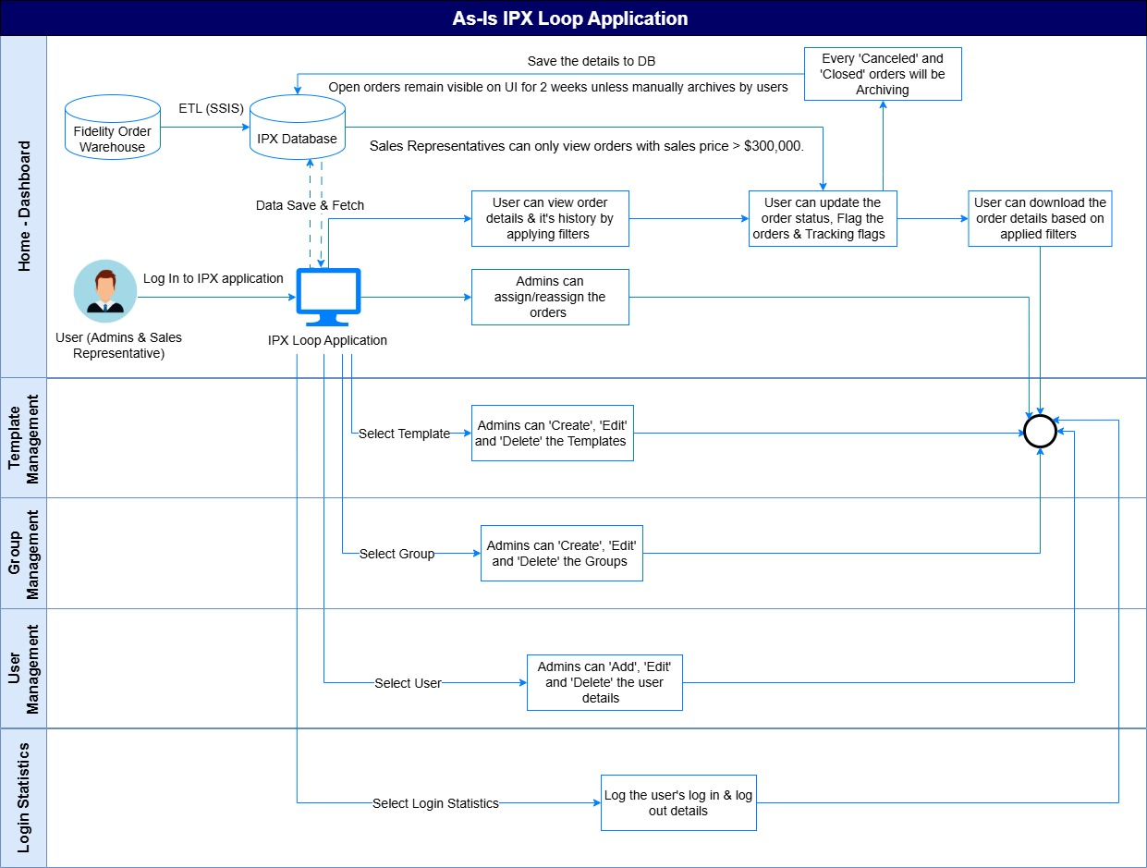

To-Be Process Flow
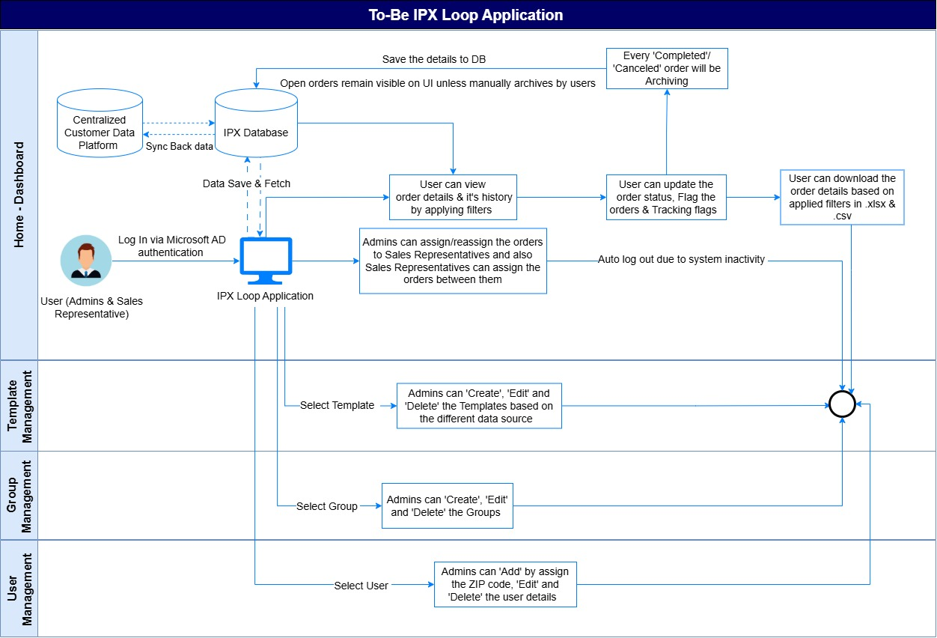

Non-Functional Requirements
Category | Requirement
Performance | Requirement: Load application data within 3 seconds  Explanation: This ensures the system responds quickly to user actions, particularly when retrieving or displaying data. It enhances user satisfaction and productivity. Performance testing should validate that under normal and peak conditions, data loads within the specified time.
Scalability | Requirement: Support up to expected concurrent users  Explanation: Scalability refers to the system’s ability to handle increased loads without degradation in performance. This includes horizontal scaling (adding more servers) or vertical scaling (upgrading existing hardware). Load testing and capacity planning are essential to ensure the system can support future growth.
Security | Requirement: End-to End encryption, role validation, password hashing  Explanation: Security ensures data protection and controlled access,  - End-to-end encryption protects data in transit from unauthorized access.  - Role validation enforces access control, ensuring users can only perform actions permitted by their roles.  - Password hashing secures stored credentials, making them unreadable even if the database is compromised.
Reliability | Requirement: Daily auto refresh of data in CDP  Explanation: Reliability ensures the system is consistently available and functions correctly. Daily auto-refresh ensures data is current and accurate, supporting timely decision-making.
UI/UX | Requirement: Modern responsive design  Explanation: Ensure the application is visually appealing and fully usable on desktop devices with support for major browsers (Microsoft Edge and Chrome). Implement a responsive design that dynamically adapts layout and functionality based on screen size, enhances accessibility, and delivers optimal user experience.
Integration | Requirement: Stable and optimized connectivity with CDP  Explanation: Integration ensures seamless data exchange between systems. Stability means the connection is reliable, while optimization ensures minimal latency and efficient data handling. This is crucial for real-time analytics and personalization.
Auditability | Requirement: Capture the updated data along with the user actions  Explanation: Auditability supports tracking and logging of changes and user activities. This is vital for compliance, troubleshooting, and security. Logs should include timestamps, usernames, and action details.
Maintainability | Requirement: Codebase structured for modular upgrades  Explanation: Maintainability ensures the system can be easily updated or enhanced. A modular codebase allows developers to make changes in isolated components without affecting the entire system, reducing downtime and risk during updates.

Assumptions
- Orders data will be maintained in CDP and synchronized to IPX DB
- Sales representatives will only have access to orders assigned to them, based on role-based access control.
- Log Statistics, Other reporting like contact, property and analytics will be developed in Phase2
- All users will authenticate via Microsoft Active Directory (SSO).
- The system will auto-refresh order data every 24 hours without manual intervention.

Risks and Mitigation
Risk | Impact | Mitigation
Data sync failure from CDP | Outdated Data | Implement retry mechanism and alert logic
Performance degradation | Slow response | Optimize queries and apply caching techniques
Unauthorized access | Data exposure | Enforce strict RBAC and Enable audit logging
UI redesign delays | Rollout slippage | Run parallel design & development sprints
Data model incompatibility | Integration errors | Perform schema validations Pre-deployment

Success Criteria
- Application deployed with new UI design and stable CDP integration
- 100% of authenticated users can access system securely
- Sales Representatives view only their relevant and assigned orders
- Orders refresh daily without manual effort
- Admins can manage Sales Representatives, reassign orders and monitor updates efficiently

Appendix A: Glossary
FOW – Fidelity Order Warehouse
CDP – Centralized Customer Data Platform
RBAC – Role Based Access control

Appendix B: Informational Purpose

Identification of Residential vs Commercial
Property type is classified based on the following rules promulgated by the National Association of Insurance Commissioners (NAIC):
Residential Policies and Non-Residential Policies
All policies insuring title to real property must be classified as either residential or non-residential (do not classify policies as “other”). Residential policies mean title insurance policies that insure the title to real property having a house, individual condominium unit, mobile home permanently affixed to real estate, or other dwelling unit intended principally for the occupancy of from one to four (1–4) families, but does not include multi-family structures intended for the use of 5+ families, undeveloped lots, or real estate intended principally for business, commercial, industrial, religious, educational or agricultural purposes, even if some portion of the real estate is used for residential purposes.
Property Type | Residential/Commercial
1-4 Family Residential | Residential
Multi-Family | Commercial
Condominium Unit | Residential
Commercial/Industrial | Commercial
Unimproved Lot | Commercial
Vacant Land | Commercial
Time Share | Residential
Government | Commercial
Manufactured Housing | Residential
Agricultural Land | Commercial
Co-op Unit | Residential
Bulk Sale | Commercial
National Commercial | Commercial

